**C64 Keyboard Controlled Kernal Switch Rev. 0**

**Prototype Testing**

# Test Description

The test was executed with different models of the C64 mainboard.

* ASSY 250407 (Long Board)
* ASSY 250425 Rev. A (Long Board) in a Commodore 64C case
* ASSY 250469 Rev. 4 (Short Board)

The Kernal Adapter (long board, short board) was selected to fit the C64 mainboard and the Kernal Switch was configured with the solder bridge CP1 accordingly.

All mainboards had a pin header (1 pin) installed to access their RESET-signal. The Kernal adapter and the Kernal switch were installed and wired.

The Kernal Adapter (Rev. 0) and the Kernal Switch (Rev. 0) was installed, a firm seat was checked for and the cable were made and installed.

The test was carried out with seven different Kernals:

|  |  |
| --- | --- |
| **Number** | **Kernal** |
| **1** | Original Commodore |
| **2** | JiffyDOS (6.01) |
| **3** | JaffyDOS (1.3) |
| **4** | EXOS v3 |
| **5** | SpeedDOS |
| **6** | DolphinDOS 2.0 |
| **7** | Turbo Tape v0.1 |
| **8** | No Kernal (long board only) |

The EPROM of the short board version contained Commodore BASIC in the first 8k and the last 8k of the long board EPROM was left empty.

# Mechanical Fit

Installation ASSY 250469 Rev. 4: The Kernal Adaptor is not colliding with any other components, some had to be bend in one direction to give some space to the PCB. The Kernal Switch was above U18, no collision detected.

RP4 had to be bent backward, slightly. All other components were far enough away. The board was seating well, the contact of J1 was sufficient. No contact between the solder side through-hole pads and components of the C64 mainboard. It might be possible to get contact between those and the ground frame of ASSY 250469, when the module is not seated well.

It is recommended to apply electrical insulation tape to the solder side south of the keyboard connectors to prevent this.

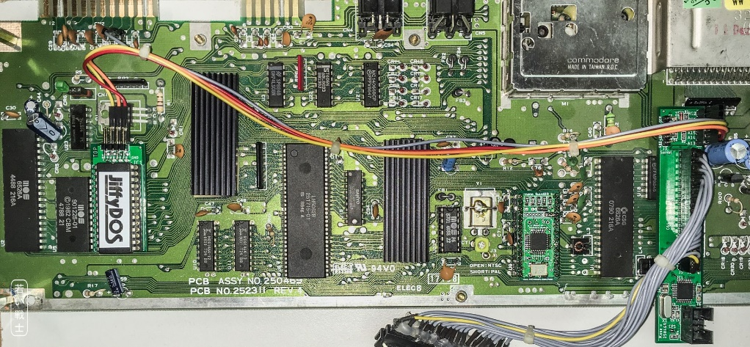

Figure 1: Installation ASSY250469

Installation ASSY 250425 Rev. A in C64C case:

The module fits on the board, it is seated properly, the contact of J1 is sufficient. The keyboard brackets do not collide with the PCB, the space is sufficient for the ICSP connector J2.

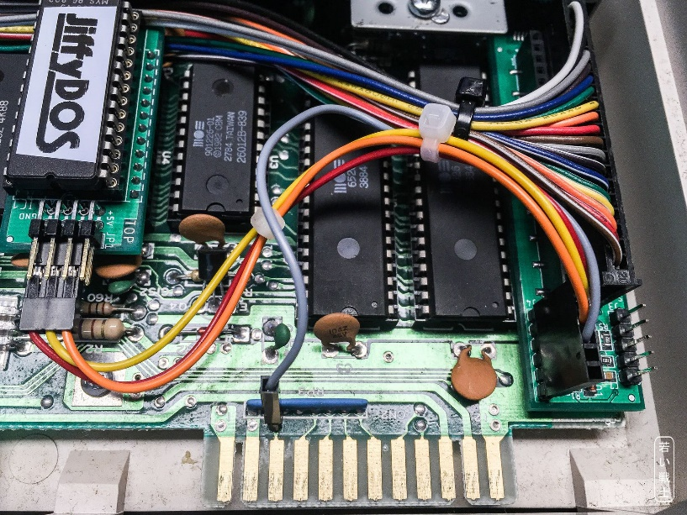

Figure 2: Installation ASSY250425

The protection diodes that are placed on top of other components on most ASSY250425 fit under the PCB. Since it is possible, that these diodes make contact with the through-hole pads of the module, it is **required to apply electrical insulation tape the solder side of the board south of the keyboard connectors.**

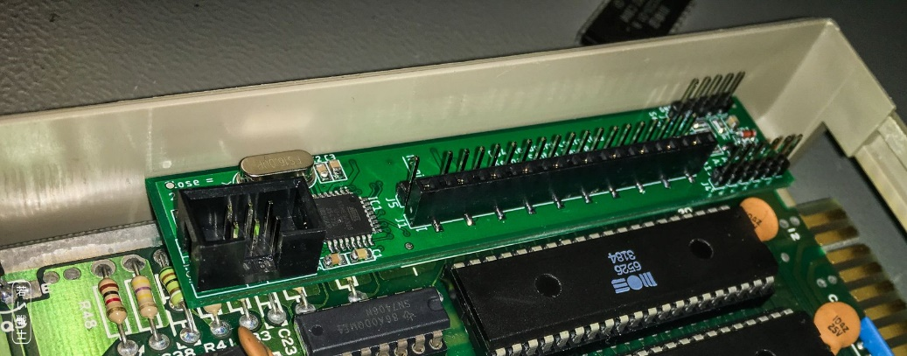

Figure 3: Installation ASSY250407 in bread bin case

Installation ASSY 250407 Rev. B in bread bin case:

The module fits on the board, it is seated properly, the contact of J1 is sufficient. The PCB does not collide with the components of the C64 south of the keyboard connector. It might be possible, that the pins of J2 scratch the resistors underneath it.

It is recommended to tape the solder side of the module south of the keyboard connector.

# Test of Functionality

## Long Board Version

The long board can switch between 8 Kernals. The EPROM was programmed with seven Kernals plus an empty 8th 8k EPROM slot.

### Holding the RESTORE key

Holding the RESTORE key for several seconds generated a RESET of the C64. This was reported on the serial interface. This test was carried out >20 times.

### Switching the Kernals

Pressing the number keys was detected properly and reported on the serial interface. Holding the RESTORE key and pressing a number key lead to changing the Kernal and resetting the C64. This worked like desired. The RESET pulse for the C64 was LOW for approximately 2 seconds.

All seven Kernals were tested several times each. No unwanted behavior was found.

### Power Cycle

Switching Kernals and at least 20 power cycles per Kernal were performed. The previously selected Kernal was executed after the power cycle. The value is properly stored in the (non-volatile) EEPROM of the microcontroller. No unwanted behavior was found.

### Switching to an Empty Kernal

After selecting a valid Kernal, it was pressed RESTORE 8 to switch to the empty Kernal. The result was a crash of the C64. One character on the screen is cycled quickly, nothing else was visible. After a timeout of several seconds, the module reported “no keyboard activity” on the serial interface, switched to Kernal 1 and reset the system. The C64 restarted with Kernal 1 (the original Kernal). The desired recovery procedure worked properly. The test was carried out several times, starting from each of the valid Kernals.

## Short Board Version

The short board can switch between 7 Kernals. The EPROM was programmed with BASIC and seven Kernals.

### Holding the RESTORE Key

Holding the RESTORE key for several seconds generated a RESET of the C64. This was reported on the serial interface. This test was carried out >20 times.

### Switching the Kernals

Pressing the number keys was detected properly and reported on the serial interface. Holding the RESTORE key and pressing a number key lead to changing the Kernal and resetting the C64. This worked like desired. The RESET pulse for the C64 was LOW for approximately 2 seconds.

All seven Kernals were tested several times each. No unwanted behavior was found.

### Power Cycle

Switching Kernals and at least 20 power cycles per Kernal were performed. The previously selected Kernal was executed after the power cycle. The value is properly stored in the (non-volatile) EEPROM of the microcontroller. No unwanted behavior was found.

# Test with Cartridges

The following cartridges were tested with the Kernal Switch:

* Final Cartridge 3+
* Power Cartridge
* Dela Dos
* Forth 64
* Diagnostic Rev. 586220
* 1541 Diagnostic/Test
* Ultimate II+
* Dead Test Rev. 781220

Except the Dead Test, all cartridges worked as desired, no unwanted behavior was found. Several power cycles were performed. The Diagnostic Rev. 586220 is configured as an EXROM cartridge, so at least initially, some keyboard scans are found.

The Dead Test cartridge does not perform keyboard scans. Thus, the Kernal Switch will reset the C64 after the time out of several seconds without keyboard scanning. This behavior was expected.

To provide non-interfered operation for this kind of cartridge, the module can be deactivated by pressing RESTORE 0 (zero). This was conducted: The Kernal was changed to Kernal 1. After switching off the C64, installing the Dead Test cartridge and powering up the computer again, the Dead Test was performed properly. The deactivation state was stored properly in the (non-volatile) EEPROM of the ATmega238P. Several tests cycles were performed. After unplugging the cartridge, the deactivation mode was switched off by selecting any of the Kernals. The state of activation was properly reported on serial interface. **The desired behavior was shown**.

# 

# Conclusion

**The Keyboard Controlled Kernal Switch is fully functional.**

Note: Not all mainboard and case type combinations could be tested. Also, the used parts may vary. An assessment of a proper installation and suitable connector seat of the keyboard connector J5 and the bottom entry connector J1 should be performed with every installation.

Again, it is required to apply electrical insulation tape to the solder side in the area south of the keyboard connectors to prevent short circuit or scratching the parts underneath the module.